ABSTRACT TITLE

First Authorª, Second Author^{b}
ªAdres
^{b}Adres
e-posta (presenter)

SUMMARY
The Turkish abstract of the paper should not exceed 500 words and should be written in Times New Roman font format in 11 pt. The spacing of the text will be 1.5 lines and the page margins (left, right, bottom and top margins) will be 2.5 cm. The title of the paper will be written in 12 pt, bold and capital letters and centred. In the abstract text, references will be given as [1] if there is only one, [1, 2] if there is more than one, etc. The references section will be organised as shown below.

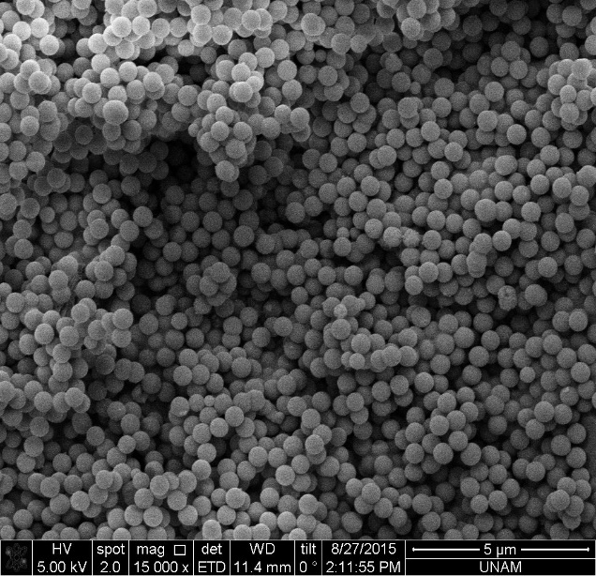

Figure 1. Figure description will be given

Keywords: It will include a maximum of 5 words written in alphabetical order, in 11 point font size and separated from each other by commas.

REFERENCES
- References used in the text will be referred to as [1], [1, 2], etc.
- The references mentioned in the text and generally utilised will be listed in this section and character
sizes of 11 pt for the title and 10 pt for the references will be chosen.
- References should be numbered as [1], [2], [3], .....
- References should be given in the order of the number they are mentioned in the text.

Article:
[1] J. van der Geer, J.A.J. Hanraads, R.A. Lupton, The art of writing a scientific article, J. Sci. Commun. 163 (2010) 51–59. https://doi.org/10.1016/j.Sc.2010.00372.
If the article is given with article number:
[2] Van der Geer, J., Hanraads, J.A.J., Lupton, R.A., 2018. The art of writing a scientific article. Heliyon. 19, e00205. https://doi.org/10.1016/j.heliyon.2018.e00205.
Book, published lecture notes, etc.:
[3] W. Strunk Jr., E.B. White, The Elements of Style, fourth ed., Longman, New York, 2000.
The book chapter published in the book is:
[4] G.R. Mettam, L.B. Adams, How to prepare an electronic version of your article, in: B.S. Jones, R.Z. Smith (Eds.), Introduction to the Electronic Age, E-Publishing Inc., New York, 2009, pp. 281–304.
Thesis, research report, etc.:
[5] B. Baki, Kurumsal Kaynak Planlaması Yazılım Seçimi, Karadeniz Teknik Üniversitesi Sosyal Bilimler Enstitüsü İşletme Bölümü, Doktora Tezi, Trabzon, 2000.
Website is:
[6] Cancer Research UK, Cancer statistics reports for the UK. http://www.cancerresearchuk.org/ aboutcancer/statistics/cancerstatsreport/, 2003 (accessed 13 March 2003).

